绝密★启用前 试卷类型：B

2008年普通高等学校招生全国统一考试(广东卷)
英 语

本试卷共12页,四大题,满分150分。考试用时120分钟。
注意事项：1. 答卷前，考生务必用黑色字迹的钢笔或签字笔将自己的姓名和考生号、试室号、座位号填写在答题卡上。用2B铅笔将试卷类型(B)填涂在答题卡相应位置上。将条形码横贴在答题卡右上角“条形码粘贴处”。
2. 选择题每小题选出答案后，用2B铅笔把答题卡上对应题目选项的答案信息点涂黑，如需改动，用橡皮擦干净后，再选涂其他答案，答案不能答在试卷上。
3. 非选择题必须用黑色字迹钢笔或签字笔作答，答案必须写在答题卡各题目指定区域内相应位置上；如需改动，先划掉原来的答案，然后再写上新的答案；不准使用铅笔和涂改液。不按以上要求作答的答案无效。
4. 考生必须保持答题卡的整洁。考试结束后，将试卷和答题卡一并交回。

I 听力(共两节。满分35分)
第一节 听力理解 (5段共15小题；每小题2分，满分30分)
每段播放两遍。各段后有几个小题，各段播放前每小题有5秒钟的阅题时间。请根据各段播放内容及其相关小题，在5秒钟内从题中所给的A、B、C项中，选出最佳选项，并在答题卡上将该项涂黑。
听第一段对话，回答第1～3题。
1. What is.1ack worried about when he starts college?
A. His former classmates will graduate this year.
B. His time off will put him at a disadvantage.
C. He will have to practice a lot.
2. After how many years did Susan return to college?
A. Three years.
B. Two years.
C. One year.
3. What advice does Susan give Jack about his study?
A. Don't expect to catch on quickly.
B. Don't take the English major.
C. Don't take too many courses.
听第二段对话，回答第4～6题。
4. What does the man think of Chinatown in San Francisco 7
A. It’s larger than his own town.
B. It’s like any other town.
C. It’s the best in the U.S..
5. Why does the Chinese New Year change every year?
A. It’s based on the different calendars.
B. It’s in the extra month.
C. It’s set as a holiday.
6. In what year was the man born?
A. Year of the Rooster.
B. Year of the Pig.
C. Year of the Ox.
听第三段独白，回答第7～9题。
7. Why is the marathon at the 1968 Olympics a truly historic event?
A. Because three runners tried very hard to win the marathon.
B. Because Bikila won his third victory in the marathon.
C. Because the last 13.1Brier won the Olympic marathon.
8. What did Wolde do when he saw Bikila drop out?
A. He stopped to assist Bikila.
B. He filled Bikila’s shoes.
C. He ran even faster.
9. Why did the crowd cheer when the last runner crossed the finish line?
A. They were surprised to see his wounded leg.
B. They were greatly moved by his spirit.
C. They thought he was the winner.
听第四段对话，回答第10～12题
10. Where did the man meet Claudia?
A. At a class discussion.
B. At a music store.
C. On the Internet.
11. What is the relation between the man and Claudia?
A. Boy friend and girl friend.
B. Close friends.
C. Web friends.
12. What does the woman suggest about greeting Claudia'?
A. Bringing her some flowers.
B. Using her family name.
C. Arriving on time.
听第五段独白，回答第13～15题。
13. How do rainforests manage to survive?
A. By storing large quantities of carbon dioxide.
B. By developing ways to protect themselves.
C. By producing a large amount of oxygen.
14. Why d0 the leaves of a tree never actually touch those of others?
A. Because it’s a way to prevent the spread of any tree diseases.
B. Because it makes it difficult for insects to eat leaves.
C. Because animals can j ump between them.
15. How much rain can rainforests produce in some areas in a year?
A. About 75％of their own rain.
B. As much as 430 inches.
C. At least 80 inches.

第二节 听取信息(共5小题；每小题1分，满分5分)
听下面一段对话，请根据题目要求，从所听到的内容中获取必要的信息，填人答题卡标号为16～20的空格中。听录音前，你将有10秒钟的阅题时间，录音读两遍。你将有60秒钟的作答时间。
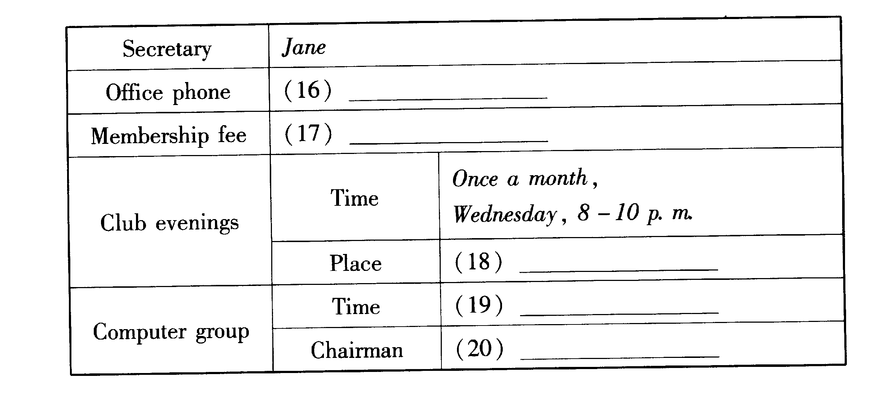

Ⅱ 语言知识及应用 (共两节，满分35分)
第一节 完形填空 (共10小题；每小题2分，满分20分)
阅读下面短文，掌握其大意，然后从21—30各题所给的A、B、C和D项中，选出最佳选项，并在答题卡上将该项涂黑。
Tales of the supernatural are common in all parts of Britain. In particular, there was (and perhaps still is) a belief in fairies(仙女). Not all of these 21 are the friendly, people-loving characters that appear in Disney films, and in some folktales they are 22 and cause much human suffering. This is true in the tales about the Changeling. These tell the story of a mother whose baby grows 23 and pale and has changed so much that it is almost 24 to the parents. It was then 25 that the fairies had come and stolen the baby away and 26 the human baby with a fairy Changeling. There were many ways to prevent this from happening: hanging a knife over the baby’s head while he slept or covering him with some of his father’s clothes were just two of the recommended 27 . However, hope was not lost even if the baby had been 28 . In those cases there was often a way to get the 29 baby back. You could 30
the Changeling on the fire--then it would rise up the chimney, and you would hear the sound of fairies’ laughter and soon after you would find your own child safe and sound nearby. 21. C. fairies 22. B cruel 23. A sick 24. D unrecognizable 25. A feared
26. C. replaced 27. D. methods 28. B. stolen 29. D. real 30. C.
21. A. babies B. believers C. fairies D. supermen
22. A. powerful B. cruel C. frightened D. extraordinary
23. A. sick B. slim C. short D. small
24. A. uncomfortable B. unbelievable C. unacceptable D. unrecognizable
25. A. feared B. predicted C. heard D. reported
26. A. covered B. changed C. replaced D. terrified
27. A. cases B. tools C. steps D. methods
28. A. missed B. stolen C. found D. lost
29. A.1ittle B. pale C. sad D. real
30. A. seize B. burn C. place D. hold

第二节 语法填空 (共10小题，每小题1.5分，满分15分)
阅读下面短文，按照句子结构的语法性和上下文连贯的要求，在空格处填入一个适当的词或使用括号中词语的正确形式填空，并将答案填写在答题卡标号为31～40的相应位置上。
Chinese proverbs are rich and they are still widely used in Chinese people’s daily life. 31 these proverbs there are often interesting stories. For example, the proverb, “plucking up a crop 32 (help) it grow”, is based on the following story.
It is said that a short—tempered man in the Song Dynasty (960—1279) was very anxious to help 33 rice crop grow up quickly. He was thinking about 34 day and night. But the crop was growing much slower than he expected.
One day, he came up with an idea 35 he would pluck up all of his crop a few inches. He did so the next day.
He was very tired 36 doing this for a whole day, 37 he felt very happy since the crop did “grow” 38 (high).
His son heard about this and went to see the crop. Unfortunately the leaves of the crop began to wither.
This proverb is saying we have to let things go in their 39 (nature) course. Being too anxious to help an event develop often 40 (result) in the contrary to our intention.
31. Behind 32. to help 33. his 34. this 35. that
36. after 37. but 38. higher 39. natural 40. results

Ⅲ 阅读 (共两节，满分40分)
第一节 阅读理解 (共15小题；每小题2分，满分30分)
阅读下列短文，从每题所给的A、B、C和D项中，选出最佳选项，并在答题卡上将该项涂黑。
A
Parents and kids today dress alike, listen to the same music, and are friends. Is this a good thing? Sometimes, when Mr. Ballmer and his 16-year-old daughter, Elizabeth, listen to rock music together and talk about interests both enjoy, such as pop culture, he remembers his more distant relationship with his parents when he was a teenager.
“I would never have said to my mom, ‘Hey, the new Weezer album is really great. How do you like it?’” says Ballmer. “There was just a complete gap in taste.”
Music was not the only gulf. From clothing and hairstyles to activities and expectations, earlier generations of parents and children often appeared to move in separate orbits.
Today, the generation gap has not disappeared, but it is getting narrow in many families. Conversations on subjects such as sex and drugs would not have taken place a generation ago. Now they are comfortable and common. And parent—child activities, from shopping to sports, involve a feeling of trust and friendship that can continue int0 adulthood.
No wonder greeting cards today carry the message, “To my mother, my best friend.”
But family experts warn that the new equality can also result in less respect for parents. “There’s still a lot of strictness and authority on the part of parents out there, but there is a change happening,” says Kerrie, a psychology professor at Lebanon Valley College. “In the middle of that change, there is a lot of confusion among parents.”
Family researchers offer a variety of reasons for these evolving roles and attitudes. They see the 1960s as a turning point. Great cultural changes led to more open communication and a more democratic process that encourages everyone to have a say.
“My parents were on the ‘before’ side of that change, but today’s parents, the 40-year-olds, were on the ‘after’ side,” explains Mr. Ballmer. “It’s not something easily accomplished by parents these days, because life is more difficult to understand or deal with, but sharing interests does make it more fun to be a parent now.”

41. The underlined word gulf in Para.3 most probably means _________.
A. interest
B. distance
C. difference
D. separation
42. Which of the following shows that the generation gap is disappearing?
A. Parents help their children develop interests in more activities.
B. Parents put more trust in their children’s abilities.
C. Parents and children talk more about sex and drugs.
D. Parents share more interests with their children.
43. The change in today’s parent-child relationship is _________.
A. more confusion among parents
B. new equality between parents and children
C.1ess respect for parents from children
D. more strictness and authority on the part of parents
44. By saying “today’s parents, the 40-year-olds, were on the ‘after’ side.” the author means that today’s parents _________.
A. follow the trend of the change
B. can set a limit to the change
C. fail to take the change seriously
D. have little difficulty adjusting to the change
45. The purpose of the passage is to _________.
A. describe the difficulties today’s parents have met with
B. discuss the development of the parent—child relationship
C. suggest the ways to handle the parent—child relationship
D. compare today’s parent—child relationship with that in the past

B
Sometimes you’ll hear people say that you can’t love others until you love yourself. Sometimes you’ll hear people say that you can’t expect someone else to love you until you love yourself. Either way, you’ve got to love yourself first and this can be tricky. Sure we all know that we’re the apple of our parents’ eyes, and that our Grandmas think we’re great talents and our Uncle Roberts think that we will go to the Olympics. but sometimes it’s a lot harder to think such nice thoughts about ourselves. If you find that believing in yourself is a challenge. it is time you build a positive self-image and learn to love yourself.
Self-image is your own mind’s picture of yourself. This image includes the way you look, the way you act, the way you talk and the way you think. Interestingly, our self-images are often quite different from the images others hold about US. Unfortunately, most of these images are more negative than they should be. Thus changing the way you think about yourself is the key to changing your self-image and your whole world.
The best way to defeat a passive self-image is to step back and decide to stress your successes. That is, make a list if you need to, but write down all of the great things you do every day. Don’t allow doubts to occur in it.
It very well might be that you are experiencing a negative self-image because you can’t move past one flaw or weakness that you see about yourself. Well, roll up your sleeves and make a change of it as your primary task. If you think you’re silly because you aren’t good at math, find a tutor. If you think you’re weak because you can’t run a mile, get to the track and practice. If you think you’re dull because you don’t wear the latest trends, buy a few new clothes. But remember, just because you think it doesn’t mean it’s true.
The best way to get rid of a negative serf-image is to realize that your image is far from objective, and to actively convince yourself of your positive qualities. Changing the way you think and working on those you need to improve will go a long way towards promoting a positive self-image. When you can pat(拍) yourself on the back, you’ll know you’re well on your way. Good luck!

46. You need to build a positive self-image when you _________.
A. dare to challenge yourself
B. feel it hard to change yourself
C. are unconfident about yourself
D. have a high opinion of yourself
47. According to the passage, our serf-images _________.
A. have positive effects
B. are probably untrue
C. are often changeable
D. have different functions
48. How should you change your serf-image according to the passage?
A. To keep a different image of others.
B. To make your life successful.
C. To understand your own world.
D. To change the way you think.
49. What is the passage mainly about?
A. How to prepare for your success.
B. How to face challenges in your life.
C. How to build a positive self-image.
D. How to develop your good qualities.
50. Who are the intended readers of the passage?
A. Parents.
B. Adolescents.
C. Educators.
D. People in general.

C
Napoleon, as a character in Tolstoy’s War and Peace, is more than once described as having “fat little hands.’’ Nor does he “sit well or firmly on the horse.’’ He is said to be “undersized.’’ with“short legs’’ and a “round stomach”. The issue here is not the accuracy of Tolstoy’s description--it seems not that far off from historical accounts but his choice of facts：other things that could be said of the man are not said. We are meant to understand the difference of a warring commander in the body of a fat little Frenchman. Tolstoy’s Napoleon could be any man wandering in the streets and putting a little of powdered tobacco up his nose—and that is the point.
It is a way the novelist uses to show the moral nature of a character. And it turns out that, as Tolstoy has it, Napoleon is a crazy man. In a scene in Book Three of War and Peace, the wars having reached the critical year of 1812,Napoleon receives a representative from the Tsar(沙皇), who has come with peace terms. Napoleon is very angry：doesn’t he have more army? He, not the Tsar, is the one to make the terms. He will destroy all of Europe if his army is stopped. “That is what you will have gained by engaging me in the war!” he shouts. And then, Tolstoy writes, Napoleon “walked silently several times up and down the room, his fat shoulders moving quickly.’’
Still later, after reviewing his army amid cheering crowds, Napoleon invites the shaken Russian to dinner. “He raised his hand to the Russian’s…face,” Tolstoy writes, and “taking him by the ear pulled it gently….” To have one’s ear pulled by the Emperor was considered the greatest honor and mark of favor at the French court. “Well, well, why don’t you say anything?’’ said he, as if it was ridiculous in his presence to respect any one but himself, Napoleon.
Tolstoy did his research, but the composition is his own.

51. Tolstoy’s description of Napoleon in War and Peace is _________.
A. far from the historical facts
B. based on the Russian history
C. based on his selection of facts
D. not related to historical details
52. Napoleon was angry when receiving the Russian representative because _________.
A. he thought he should be the one to make the peace terms
B. the Tsar's peace terms were hard to accept
C. the Russians stopped his military movement
D. he didn’t have any more army to fight with
53. What did Napoleon expect the Russian representative to do?
A. To walk out of the room in anger.
B. To show agreement with him.
C. To say something about the Tsar.
D. To express his admiration.
54. Tolstoy intended to present Napoleon as a man who is _________.
A. ill-mannered in dealing with foreign guests
B. fond of showing off his iron will
C. determined in destroying all of Europe
D. crazy for power and respect
55. What does the last sentence of the passage imply?
A. A writer doesn’t have to be faithful to his findings.
B. A writer may write about a hero in his own way.
C. A writer may not be responsible for what he writes.
D. A writer has hardly any freedom to show his feelings.

第二节 信息匹配 (共5小题；每小题2分，满分10分)
阅读下列应用文及相关信息，并按照要求匹配信息。请在答题卡上将对应题号的相应选项字母涂黑。
以下是为留英学生编写的系列留学指南的简介：
A. The number—one guide to what to study in the UK
This two-volume Guide features up-to-date and in-depth information about UK course options and institutions. It also includes course charts, teaching and research ratings, and advice on choosing your course.

B. The A to Z of where to study in the UK
A reference directory of UK institutions belonging to the British Council’s Education Counselling Service. Includes easy-to-use comparative data on everything from accommodation to courses and fees.

C. The essential online guide to UK education
This site gives you instant access to a wide range of information on studying and living in the UK, including hotlinks to the British Council’s Virtual Campus and institutions’ own web sites.

D. The practical guide to making the most of your UK experience
This fully updated book features the latest information about study opportunities, traveling to the UK, arranging accommodation, working in the UK, financial and legal matters, and student life.

E. New guide to choosing the right UK course
Every year, The Times newspaper compiles a league table of all the UK's ninety-seven universities. This is published as The Good University Guide, which features over fifty tables ranking universities by degree subject.

F. The magazine that shows why so many international students choose to study in the UK
If you’ve enjoyed reading this magazine and want to keep up with the latest UK student news and views, place your order now for issues 3 and 4.

以下是留英指南图书或杂志的封面，请匹配封面与其对应的简介：
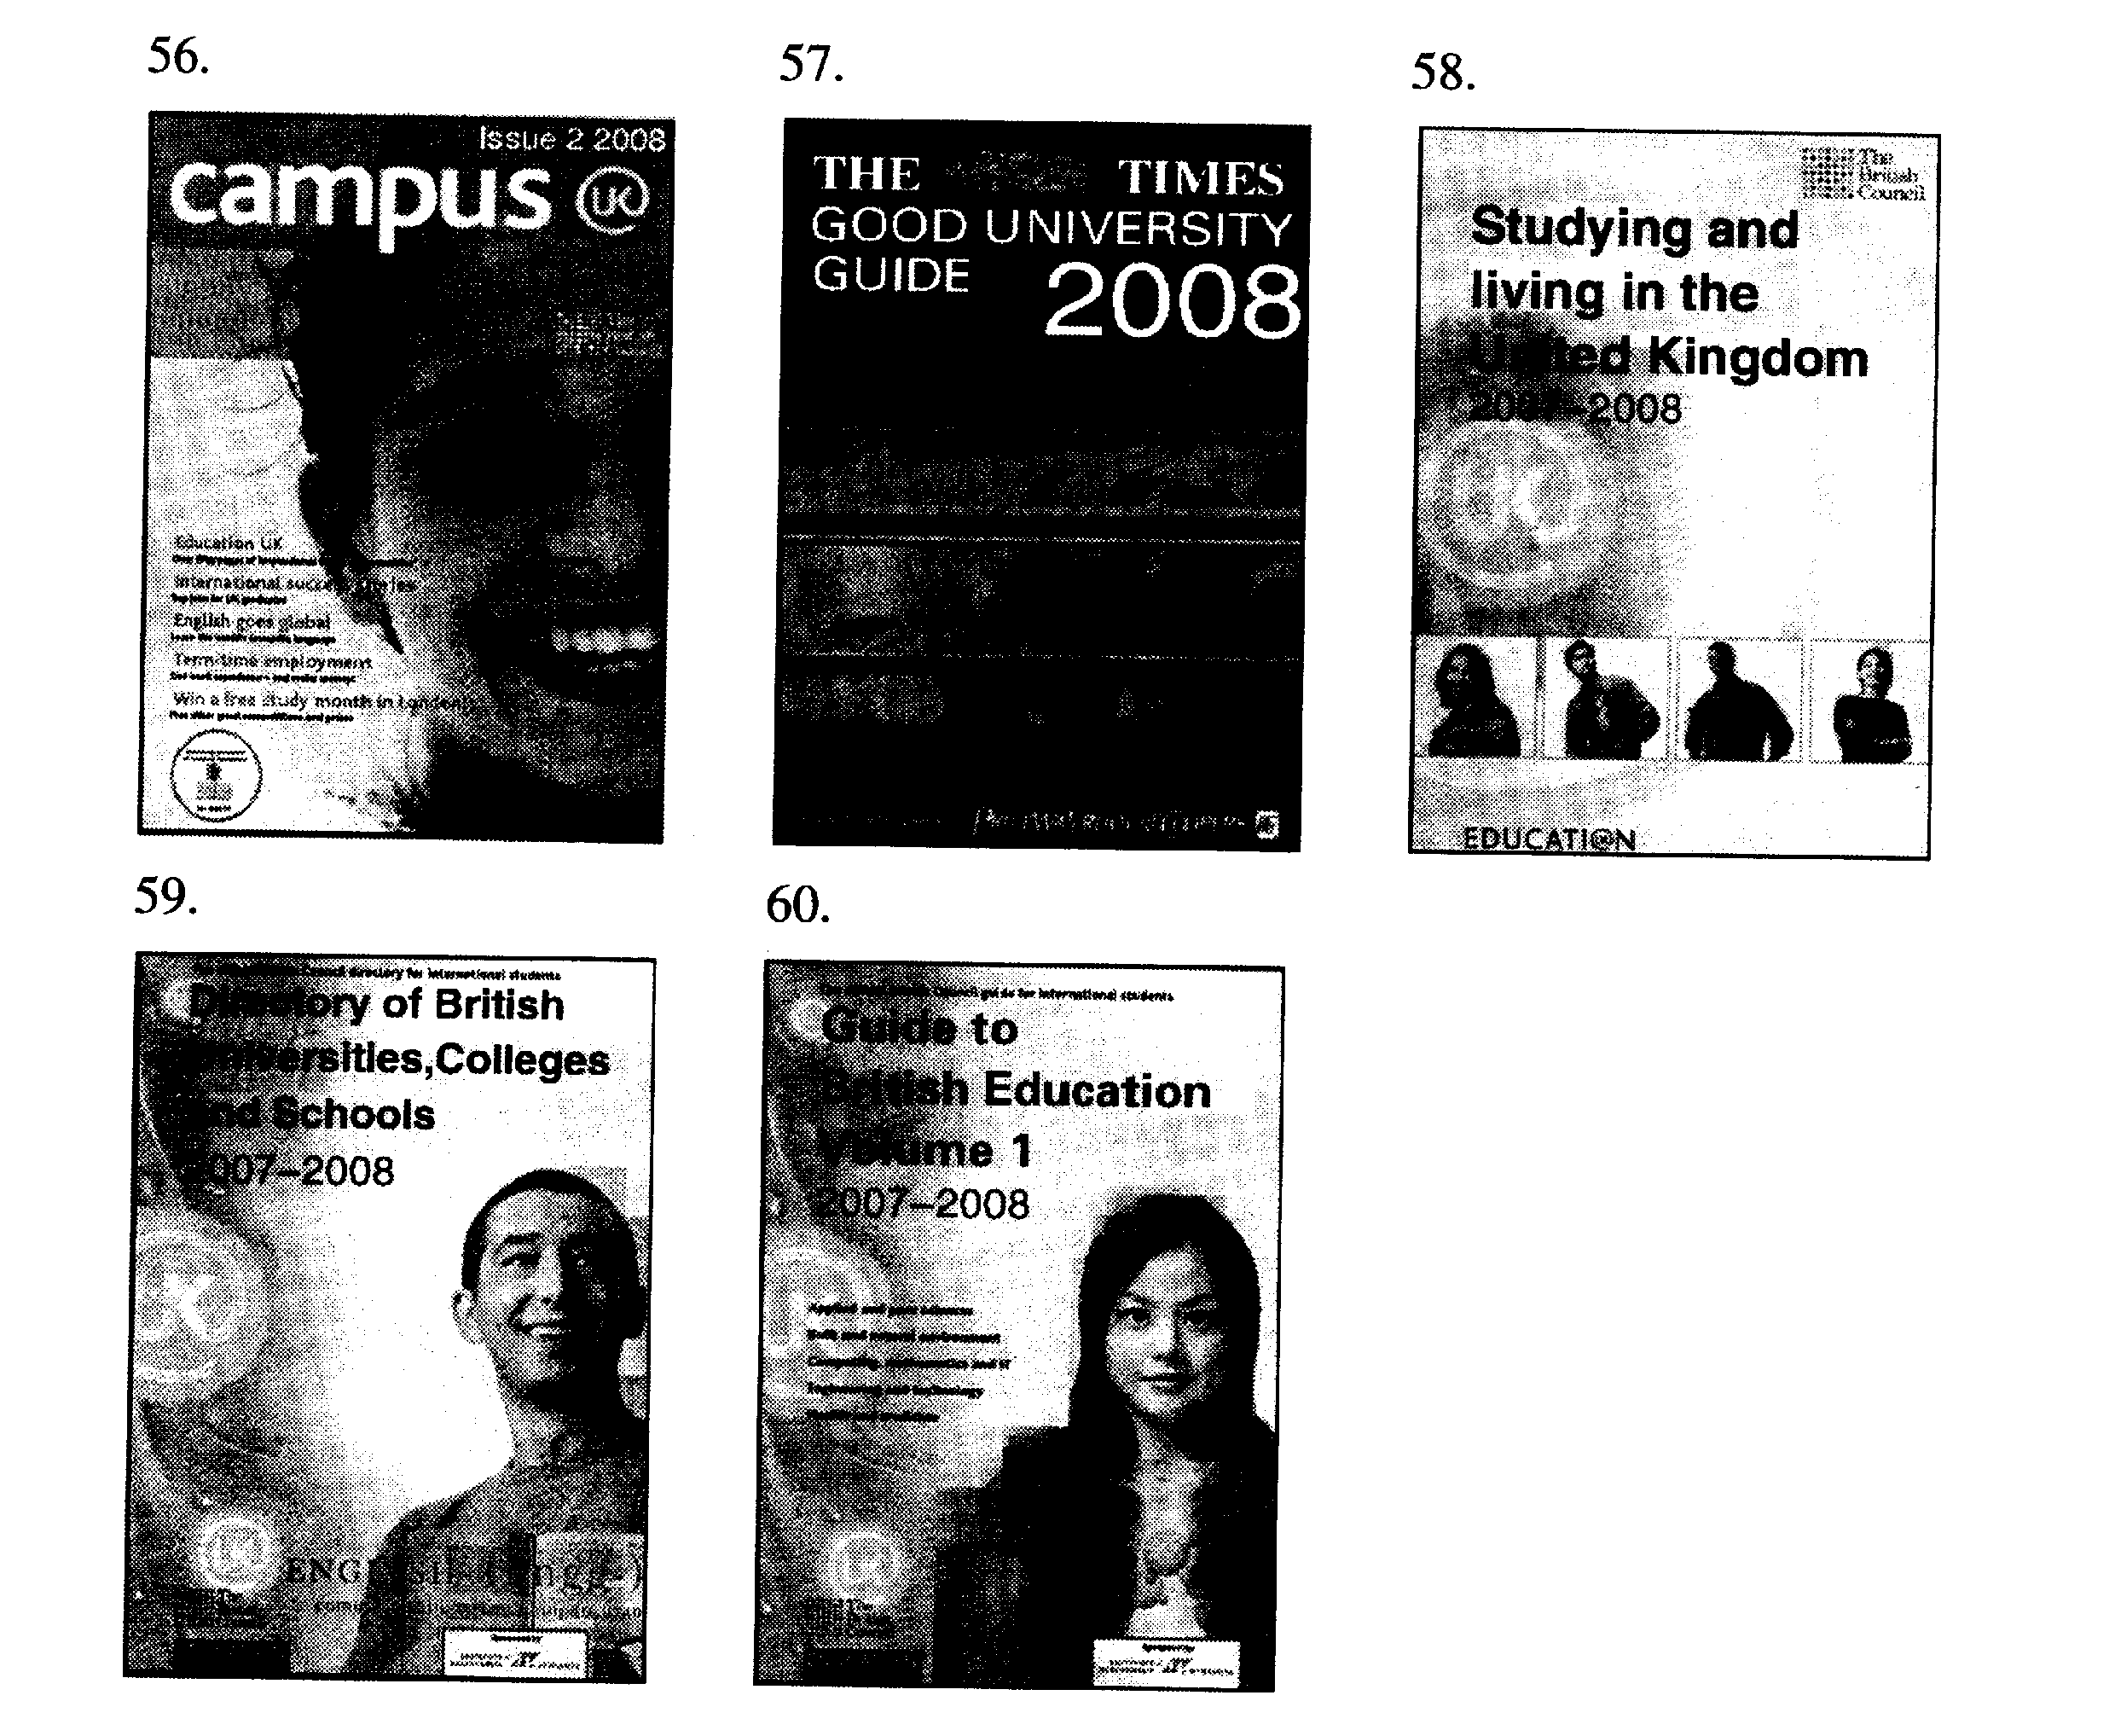

Ⅳ 写作(共两节，满分40分)
第一节 基础写作 (共1小题，满分15分)
你很荣幸地成为2008北京奥运会的一名志愿者，负责编写奥运比赛项目的英语介绍。
[写作内容]
请根据以下中文提纲，编写射击项目的英语介绍：
背景：射击最初只是生存工具，19世纪末才发展成为一项体育运动。
1896：第一次成为奥运项目
1904：中断
1928：中断
1932：重回奥运会
1968：第一次允许妇女参加奥运射击比赛
现状：稳步发展，1896奥运会只有三项射击项目，现今有17项。
[写作要求]
只能使用5个句子表达全部内容
[评分标准]
句子结构准确，信息内容完整，篇章结构连贯。

第二节 读写任务 (共1小题,满分25分)
阅读下面的短文，然后按照要求写一篇150词左右的英语短文。
Hi, I am Mike. I just went through my first year of college. The toughest part on me at first was the general adjustment.1 went to a very small high school where my mom was a teacher and she did practically everything for me. But at the college I needed to know some basic life skills. such as balancing a check—book, laundry, and the things you have to be able to handle that I never thought of in the high school! It was really tough for me at first and I got badly homesick.
Once that first semester was over and I got used to the college life, I loved it—good facilities, helpful instructors. and a good library. The Students’ Union organizes various parties every week. I also go to cinemas and concerts, and often spend Saturday nights in pubs and clubs.
One thing I think is important is to get yourself active in things. I was on the dance team in college and met a ton of people that way ··· it was so much easier to make friends when you had a common ground.

[写作内容]
学校最近组织了一次中美学生交流活动，你参加其中的“大学校园生活”讨论。听完Mike的发言之后，你准备写一份发言稿，题目是“Preparing Myself for College Life”，内容要点包括：
1. 以约30个词概括Mike的发言要点；
2. 然后以约120个词谈谈你理想的大学生活，内容包括：
(1) 对中学生活的感受；
(2) 理想的大学生活；
(3) 中学生活和大学生活的差别，以及你打算如何适应。
[写作要求]
1. 在作文中可以使用自己亲身的经历或虚构的故事，也可以参照阅读材料的内容但不得直接引用原文中的句子；
2. 作文中不能出现真实姓名和学校名称。
[评分标准]
概括准确，语言规范，内容合适，篇章连贯。

2008年广东高考英语试卷参考答案

【完形填空标准答案】
21. C. fairies 22. B cruel 23. A sick 24. D unrecognizable 25. A feared
26. C. replaced 27. D. methods 28. B. stolen 29. D. real 30. C. place

答案解析：
21. C 指前文的fairies,和下文的they一致。
22. B 跟friendly相对，当然是残酷无情。
23. A 由后文changed so much可知, 且与pale 并列。
24. D由changed so much可知。
25. A 把自己的孩子换走，当然害怕。
26. C 搭配，replace…with… .
27. D 由后文ways可知。
28. B 根据前文逻辑关系可知。
29. D 把自己真正的孩子换回来。
30. C 固定搭配，把Changeling 放在火上。

【语法填空标准答案】
31. Behind 32. to help 33. his 34. this 35. that
36. after 37. but 38. higher 39. natural 40. results

答案解析：
31. Behind 这些谚语背后都有有趣的故事。
32. to help 不定式做目的状语。
33. his 让自己的水稻长得快。
34. this 想刚说过的事情用this.
35. that 同位语从句。
36. after 劳累一整天后疲劳。
37. but 根据逻辑关系应该用转折语气。
38. higher 和拔苗之前比较更高。
39. natural 词性变化，应该用形容词。
40. results Being too anxious to help an event develop 做主语，谓语用单数；客观真理用一般现在时。

【阅读理解参考答案】
41-45 CDBAB 46-50 CCDCD 51-55 CADDB

【信息匹配标准答案】
56—60 FECBA

II.语言知识及应用
第一节 完型填空
21. C 指前文句子中提及的 “a belief in fairies”, 和下文“they”一致。
22. B 从半否定句子“Not all of these … are the friendly, people-loving…”，可知文中所提fairies非友善、受人爱戴之类型；frightened, 用于修饰人的自身感觉，此处不合适。
23. A 从并列的形容词“pale”和动词 “change” 可知。
24. D 从句中“change so much” 可知。
25. C It was heard that… 听说……
26. C 固定搭配 replace…with …替代。
27. D 呼应前文所述“many ways”。
28. B 前文有“the fairies had come and stolen the baby away…” 。
29. D 仙女用“Changeling” 把婴儿调包了。用这两种方法要把真正的孩子找回来。
30. C 固定搭配，把Changeling放在火上。
第二节 语法填空
31. Behind “behind the story/ the proverbs…” 在故事/预言背后。
32. to help 动词不定式做目的状语。
33. his/the 此处有“help sb. do sth.”，所以，不该再填入其他动词，而选用his/the特指“他自己的庄稼”。
34. this/it 指代前文所提到的事情：主人公想要庄稼快点长大的愿望。
35. that that 引导后面的句子，作同位语从句。
36. after “after + V-ing” 在做某事之后。
37. but 连词“but”表转折，对比前句的“tired”和后句的“happy”。
38. higher 表述在主人公揠苗之后，庄稼比以前高了，因此此处该用形容词比较级。
39. natural 在形容词性物主代词“their”和名词“course”之间，用nature 的形容词形式 natural 修饰 “course”，意思为“自然的过程”
40. results “result”在此处为动词作谓语，主语是“Being too anxious to…” ,动名词做主语表单数。
III.阅读
第一节 阅读理解
（A）
41. B 从后一句“…move in separate orbits”可知。
42. C 从文中“… , but it is getting narrow” 及 “such as sex and drugs” 的例举。
43. B 从Para. 6 “…family expert warn that…”得知目前的亲子关系的新转变。
44. A Para. 7 “the 1960s as a turning point. Great cultural changes led to more open communication…” 使得 the 40-year-olds 能顺应变化的趋势。
45. B 本文阐述了亲子关系的发展。
（B）
46. C 从Para1 最后一句“If you find that believing yourself is a challenge”可知意思是“缺乏自信”。
47. C 从Para 2 第二句，“This image includes…”可知，self-image是可变的。选项A，不全面。选项D，句中所提是image所包含的内容而非功能。
48. D 从Para2 最后一句“Thus changing the way you think is the key to …” 可知。
49. C 文章仅仅阐述了如何避免消极，并建立积极向上的自我形象。选项A、B、D太空泛。
50. D 文章中，未有涉及年龄限定的文字，因此不能选A或B （adolescents青少年）。
(C)
51. C 从Para1 第四句“…it seems not that far off from…but his choice of facts” 可知。
52. A 文章所述之故事，是为了刻画拿破仑爱面子、争强好胜的人物性格。
53. A 前一段提及，俄罗斯使者带着和平条约到来，使得拿破仑王者尊严受损，因此用餐时，拿破仑想借着“taking him by the ear pulled it gently…”给使者一个下马威。
54. D 从拿破仑接见俄罗斯使者一事，可知拿破仑是一个好强、对权力和尊严狂热的人。
55. A “findings”从“research”中来，意思是，即使调查发现史实是这样，但作者也不需要原原本本地照搬事实来进行创作。
第二节 信息匹配
56. F 57. E 58. C 59. B 60. A
Passage A 出现“two-volume”证明此书分两册，与题60 “Volume 1”吻合。
Passage B 出现“directory of UK.” 与题59 书名吻合。
Passage C 出现“information on studying and living in the UK.”， 与题58书名吻合。
Passage D 所指之书，范围广，内容包罗万象，与任何一题的封面不相匹配。
Passage E 关键词“the Times”
Passage F 出现“issues 3 and 4” 与题56中封面 的“issue 2” 相关联。
IV. 写作
第一节 基础写作
重点词汇：shooting survival tools Olympic event develop steadily
第二节 读写任务
写作思路：1. 题目中所要求的内容必须全部包含
2. 按要求，该文章应分为四段。第一段：概括Mike的发言要点；第二段：对中学生活的感受（文字比例小一些，大概25个词）；第三段：理想的大学生活，融入与中学生活的对比（大约50个词）；最后一段：表明自己将如何在大学生活中创造、实现自我价值。

