2007年普通高等学校招生全国统一考试（北京卷）
英 语
第一卷（选择题 共115分）
第一部分：听力理解（共两节，30分）
第一节（共5小题；每小题1.5分，共7.5分）
听下面5段对话。每段对话後有一道小题，从每题所给的A,B,C三个选项中选出最佳选项。听完每段对话後，你将有10秒中的时间来回答有关小题和阅读下一小题，每段对话你将听一遍。
例：What is the man going to read?
A.A newspaper
B.A magazine
C A book
答案是A
A.
B.
C.

- Where is the man from?
A. Atlanta
B. New York
C. Washington,D.C
2.How much is the man’s telephone bill?
A. $50
B. $24
C. $30
3.What does the woman want to watch?
A. News
B. “Animal World”
C. Movie
4.Which apartment is the woman interested in?
A. The one-bedroom apartment
B. The two-bedroom apartment
C. The three-bedroom apartment
5.What is the woman doing
A. Giving advice
B. Asking the way
C.Making a request

第二节（共15小题；每小题1.5分，共22.5分）
听下面6段对话或独白，每段对话或独白後有几道小题，从每题所给的A. B. C.三个选项中选出最佳选项。听每段对话或独白前，你将有5秒钟的时间阅读每小题。听完後，每小题将给出5秒钟的作答时间。每段对话或独白你将听两边。

听第6段材料，回答第7至7题。
6.Why is the woman late?
A. She missed the bus
B. She couldn’t start her car
C. She coulden’t find the key
7.Where are the two speakers?
A. At a garage
B. At a bus stop
C. At a restaurant
听第7段材料，回答第8至9题。
8.What are the two speakers going to do?
A. Go shopping
B. Visit a church
C. See an exhibition
9.What do we learn about the man
A. He is a tour guide
B. He words in a shop
C. He lives in the city
听第8段材料，回答第10至11题
10.Who is going to give the speech?
A. Mar
B. Susan
C. John
11.What is the speech about?
A. A project
B. A city
C. A job
听第9段材料，回答第12至14题
12.Where does the woman work>
A. Tokyo
B. London
C. Oxford
13.What are the speakers going to do together tomorrow evening?
A. Visit Hane
B. Have dinner
C. See customers
14.Who is probable Jane?
A. Tony’s customer
B. Tony’s boss
C. Tony’s wife
听第10段材料，回答第15至17题
15.Who is the woman talking to?
A. A student
B. A teacher
C. A secretary
16.What does the man say about Frank?
A. He is quiet
B. He is active
C.He is honest
17.What does the woman think good student should be like?
A. They should ask questions
B. They should pay attention in class
C. They should not be afraid of making mistakes

第二部分：知识运用（共两节，45分）
第一节 单项填空（共15小题：每小题1分，共15分）
从每题所给的A. B. C.D四个选项中，选出可以填入空白处的最佳选项，并在答题卡上将该项涂黑。
例：It’s so nice to hear from her again.______,we last met more than thirty year ago
A.What ‘s word B. That’s to say
C.In other words D. Believe it or not

答案是D

21.This is a junior school.You should go to a senior school _____girls of your age.
A.for B. about C. from D. to

22.I looked under _____bed and found ______bokkd I lost last week.
A.the; a B. the: the C. 不填；the D. the:;不填

23.We shouldn’t spent our money testing so many people,most of _____are healthy
A. that B.which C. what D. whom

24.-----How can I apply for an online course?
------Just fill out this form and we _____ what we can do four you.
A.see B.are seeing C. have seen D. will see

25.---Where’s that report?
---I brought it to you ____you were in Mr.Black’s office yesterday.
A. if B. when C. because D. befor

26. In crowded places like airports and railway stations,you___ take care of your luggage.
A. can B. may C. must D. will

27. He has made a lot of films,but ____ good ones.
A.any B. some C. few D. many

28.---Excuse me sir,where is Room 301?
---Just a minute.I’ll have Bob ____you to your room.
A.show B.shows C. to show D. showing

30.The new group of students is better-behaved than the other group who stayed here ___.
A. early B. earlier C. earliest D. the earliest

31.You have failed two tests.You’d better start working harder,____you won’t pass the course.
A.and B. so C. but D. or

32.I got caught in the rain and my suit____.
A. has ruined B. had ruined C. has been ruined D. had been ruined

33.Leave your key with a neighbor ___ you lock yourself out one day
A. ever since B. even if C. soon after D. in case

34.When you’ve finished with that book,don’t forget to put it back one the shelf,____?
A. do you B. don’t you C. will you D. won’t you

35.----It was really very kind of you to give me a lift home.
-----Oh,don’t mentiong it.I _____past your house anyway.
A. was coming B. will come C. had come D. have come

第二节 完形填空（共20小题；每小题1.5分，共30分）
阅读下面短文，掌握其大意，从每题所给的A.B.C.D. 四个选项中，选出最佳选项，并在答题卡上将该选项涂黑。
Ban the Band(乐队)
Every year,out school has a dance for all the students.It’s a little funny seeing friends in clean shoes and trousers or colorful __36____,instead of the usual school uniform.
Most of us think the dance is great _37___ ---even the teachers enjoy being there.___38__,two weeks ago someone said that there would be no ___39___ band this year ——only CDs.
“I don’t __40__ it!”Amy cried out during the lunch break.
“Someone said the school couldn’t __41__ a band,and they think it’s too noisy anyway/”added Daniel.
“Well,I don’t think it’s __42__ enough without a band!”declared Angela.”and I’m going to see what can be done.”
Angela was as good as her __43__.In the afternoon she went to see the school headmaster who agreed to give the __44__ some more thought.And he suggested that one __45__for having a band was to increase the price of each ticket from $5 to $10.Angela had to ___46__ out whether the students would like to do that.
“I need all of you to help me,”she __47__to our group before school the next day.”Mr.Berry gave me a list of all the names,and suggested we ask each one their __48__ about the band and the extra cost.”
___49___ the day we asked around as Angela suggested,and wrote down peoples’s feelings about the band and the cost.We were amazed how much __50__ there was for the band and everyone agreed to pay the extra $5.
“I’m surprised,”smiled Mr.Berry,when we gave him the __51__.”I realty thought that only a few people __52__ their band and that the cost would be too high.OK.Angela,your next __53__is to find a good band and line them up for the dance. ”
Angela was all smiles and __54__ the news to Amy and Daniel.”You’re __55__,”smiled Daniel to Angela as he thought how close they came to having a less than perfect dance.

36. A. shapes B. dressed C. flowers D. pictures
37. A. fun B. work C. effort D. progress
38. A. Besides B. Otherwise C. However D.Therefore
39. A. new B. live C.foreign D.narching
40. A. mean B.need C. accept D.believe
41 A. lead B.serve C.afford D.form
42. A. good B. clear C.useful D.easy
43. A. look B.behavior C.mind D.word
44. A. schedule B.situation C.view D.action
45. A.possibility B.concern C.decision D.chance
46. A. call B.find C.carry D.point
47. A.admintted B.replied C.apolpgized D.announced
48. A.knowledge B.instruction C.opinion D.information
49. A. On B. For C. By D.During
50. A.trust B.money C.support D.care
51. A.results B.notices C.questions D.examples
52. A.welcomed B.wanted C.defended D.invited
53. A.task B.business C.exercise D.duty
54. A.showed B.wrote C.broke D.read
55. A.amusing B.interesting C.exciting D.amazing

第三部分：阅读理解（共20小题；每小题2分，共40分）
阅读下列短文，从每题所给的A. B. C. D.四个选项中，选出最佳选项，并在答题卡上将该项涂黑。
A
EXERCISE IN EXACTLU 4 MINUTES PER DAY!
$14,615
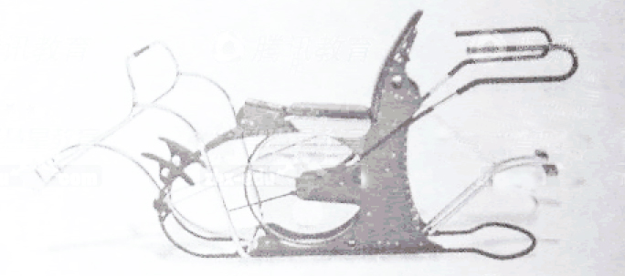
TIME IS IT.Over 92% of people who own exercise equipment and 88% of people who own health club memberships do not exercise.A 4-minute complete workout is no longer hard to believe fot all the pelple who have bought our excellent Range for 30 days end up buying it,due to the health benefits experienced during that tryout and the ROM performance score that tells the story of health and fitness improvement.At under 20 cents per use the 4-minute Rom exercise is the least expensive full body complete exercist a person can do,How do we know that it is under 20 cents per use?Over 90%of Rom machines go to private homes,but we have a few that are in commercial use for 12 years and they have endured over 80,000 ueses each,without need of repair.The ROM 4-minute workout is for people from 10 to over 100 years old and highly trained athletes as well,The ROM balances blood sugar,and repairs bad backes and shoulders.Too good to be true?Get out free video and see for yourself.The best proof for us is that 97%of rentals become sales.Please visit our website at www.fitness.com or call(800)123-6460/
Pactory Showroom:EOMFAB.823 Main Street,Batom Ronge,LA70893
Fax(800)123-6461 Email:sakes@fitness.com
56.What is ROM?
A.A piece of exercise equipment B.A club membership card
C.A commercial health club D.An electric wheelchair
57.How many people bought ROM after trying it out?
A.92% B.88% C.97% D.90%
58.One setting point of ROM is that ____
A. it makes full body exercise possible in 4 minutes
B. it can kill back and shoulder pains in 10 minutes
C.it needs no repair in the first 20years
D.it is sold on a 3-month trial basis
59.The advertisement is made believable by ___
A. telling stories B.using figures
C.making comparisons D.asking questiongs

B
The Book Of Life
So far,scientists have named about 1.8 million living species(物种),and that’s just a small number of what probably exists on Earth.With so many plants,animal,and other living things covering the planet,it can be tough to figure out what type of grass is growing by the roadside or what kind of bird just flew by.
A soon-to-be-started Web site might help.An international term of researchers has announced the creation of Web-based Encyclopedia(百科全书) of Life (EoL).The project aims to list every species on Earth in a single,easy-to-use reference guide.
To get the encyclopedia started,the creators will use information from scientific databases(数据库)that already exist.And eventually,in special sections of the site,non-scientists with specialized knowledge will come to helf.Bird-watchers,for example, will be able to input what birds they’ve seen and where. To make sure the encyclopedia is accurate, scientists will review much of the information added to it.
As the EoL develops,you might find it useful for school. Projects,The site will feature (以……为特色) special pages for kids who are studying ecosystems in their neighborhoods.Another convenient feature of the EoL is that you’ll be able to pick the level of detail you want to see to match your interests,age,and knowledgs.
It now takes years for scientists to collect all the data they need to describes and analyze species.The creators of the Encyclopedia of Life hope that their new fool will speed up that process.

60.The Web based EoL aims to ___
A. fine out what covers the earth
B. list all living things on Earth
C.work out the number of birds
D.save the existing plants
61.One characteristic of the EoL is that ____
A. it is run by school students
B. it focuses on different types of grass
C. it provides different levels of information
D.it allows non-scientists to review its data
62. In the last paragraph,”that process”means ___
A. analyzing species B. creating a new tool
C. collecting data D. describing species

C
Lying in the sun on a rock,the cougar(美洲豹)saw Jeb and his son,Tom before they saw it.Jeb put his bag down quickly and pulled his jacket open with both hands,making himself look big to the cougar,It worked.The cougar hesitated,ready to attack Jeb,but ready to forget the whole thing,too.
Jeb let go of his kacked,grasped Tom and held him across his body,making a cross.Now the cougar’s enemy looked even bigger,and it rose up,ready to move away,but unfortunately Tom got scared and struggled free of Jeb.
“Tom,no”shouted his father.
But Tom brokd and ran and that’s the last thing you do with a cougar.The second Tom broke free,Jeb threw himself on the cougar,just as it jumped from the rock.They hit each other in mid-air and both fell,The cougar was on Jeb in a flash,fotgeiting about Tomm,which was what Jeb wanted.
Cougars are not as big as most people think and a determined manstands a chance,even with just his fists.As the cougar’s claws(爪子)got into his left shoulder,Jeb swung his fist at its eyes and hit hard.The animal howled（吼叫）and put its head back.Jeb followed up with his other fist.Then out of the corner of his eye.Jeb saw Tom.The boy was running back to help his father.
“Knife,Tom,”shouted Jeb.
The boy ran to his father’s bag,while Jeb strated shouting as well as hitting,to keep the cougar’s attention away from Tom.Tom got the knife and ran over to Jeb.The cougar was moving its head in and out,trying to find a way through the wall Jeb was making out of his arms.Tom swung with the knife,into the cougar’s back.It howled horribly and ran off into the mountains.
The whole fight had taken about thirty seconds.

63.Why did Jeb pull his jacket open when he saw the cougar?
A. To get ready to fight
B. To frighten it away
C. To protect the boy
D. To cool down
64.What do we know about cougars?
A. They are afraid of noises
B. They hesitate before they hit
C. They are bigger than we think
D. They like to attack running people
65.How didi Jeb try to hold the cougar’s attention?
A. By keeping shouting and hitting
B. By makding a wall out of his arms
C. By throwing himself on the cougar
D. By swinging his fists at the cougar’s eyes
66.Which of the following happened first?
A. The cougar jumped from the rock
B. Tom struggled free of his father
C. Jeb asked Tom to get the knife
D. Jeb held Tom across his body

D
The Best of Friends
The evidence for harmony may not be obvious in some families.But it seems that four out of five young people now get on with their parents,which is the opppsite of the popularly held image(印象)of unhappy teenagers locked in their room after endless family quarrels.
An important new study into teenage attitudes surprisingly shows that their family life is more harmonious than it has ever been in the past.”We were surprised by just how positive today’s young people seen to be about their families,”said one member of the research team.”They’re expected to be rebellious(叛逆的) and selfish but actually they have other things on their minds;they want a car and material goods,and they worry about whether school is serving them well.There’s more negotiation(商议) and discussion between parents and children,and children expect to take part in the family decision-making process.They don’t want to rock the boat.”
So it seems that this generation of parents is much more likely than parents of 30 years ago to theat their children as friends.”My parents are happy to discuss things with me and willing to listen to me,”says 17-years-old Daniel Lazall.”I always tell them when L’m going out clubbing.As long as they know what I’m doing,they’re fine with it.”Susan Crome,who is now 21,agrees.”Looking back on the last 10 years,there was a lot of what you could call negotiation.For example,as long as I’d done all my homework,I could go out on a Saturday night.But I think my grandparents were a lot stricter with my parents than that.”
Maybe this positive view of family life shoululd not be unexpected.It is possible that the idea of teenages rebellion is not rooted in real facts.A researcher comments,”Our surprise that teenagers say they get along well with their parents comes because of a brief period in out social history when teenagers were regarded as different beings.But that idea of rebelling and breaking away from their parents really only happened during that one time in the 1960s when everyone rebelled.The normal situation throughout history has been a smooth change fromm helping out with the family business to taking it over.”
67.What is the popular images of teenagers today?
A. They worry about school
B. They dislike living with their parents
C. They have to be locked in to avoid troubles
D. They quarrel a lot with other family members
68.The study shows that teenagers don’t want to ___
A. share family responsibility
B. cause trouble in their families
C. go boating with their family
D. make family decisions
69.Compared with parents of 30 years age,today’s parents___.
A. go to clubs more often with their children
B. are much stricter with their children
C. care less about their children’s life
D. give their children moren freedom
70.According to the authour,teenage rebellion____.
A. may be a false belief
B. is common nowadays
C. existed only in the 1960s
D. resulted from changes in families
71.What is the passage mainly about?
A. Negotiation in family
B. Education in family
C. Harmony in family
D. Teenage trouble in family
E
Hunting
The days of the hunter are almost over in India.This is partly because there is practically nothing left to kill,and partly because some steps have been taken,mainly by banning tiger-shooting,to protect those animals which still survive.
Some people say that Man is naturally a hunter.I disagree with this view.Surely out earliest fordfathers,who at forst possessed no weapons,spent their time digging for roots,and were no doubt themselves often hunted by meat-eating animals.
I believe the main reason why the modern hunter kills is that he thinkds people will adminre his courage in overpowering dangerous animals.Of course,there are some who truly believe that the killing is not really the important thing,and that the chief pleasure lies in the joy of the hunt and the beauties of the wild countrysidel.There are also those for whom hunting in fact offers a chance to prove themselves and risk death by design;these men go out after dangerous animals like tigers,even if they say they only do it to rid the countryside of a threat.I can respect reasons like these,but they are clearly different from the need to strengthen your high opinion of yourself.
The greatest big-game hunters expressed in their writings something of these finer motives(动机).One of them wrote.
“You must properly respect what you are after and shoot it cleanly and on the animal’s own territory(领地)。You must fix forever in your mind all the wonders of that particular day.This is better than letting him grow a few years older to be attacked and wounded by his own son and eventually eaten,half alive,by other animals,Hunting is not a cruel and senseless killing – not if you respect the thing you kill,not if you kill to enrich your memories,not if you kill to feed your people.”
I can understand such beliefs,and can compare these hunters with those who hunted lions with spears(矛) and bravely caught them by the tail.But this is very different from many tiger—shoots I have seen,in which modern weapons were used.The so—called hunters fired from tall trees or from the backs of trained elephants.Such methods made tigers seem no more dangerous than rabbits.
72.Theere is no more hunting in India now partly because___.
A.it is dangerous to hunt there
B.hunting is already out of date
C.hunters want to protect animals
D.there are few animals left to hunt
73.The author thinks modern hunters kill mainly____.
A.to make the countryside safe
B.to earn people’s admiration
C.to gain power and influence
D.to improve their health
74.What do we learn about the big-game hunters?
A.They hunt old animals
B.They mistreat animals
C.They hunt for food
D.They hunt for money
75.What is the author’s view on the tiger-shoots he has seen?
A.Modern hunters lack the courage to hunt face-to-face
B.Modern hunters should use more advanced weapons
C.Modern hunters like to hunt rabbits instead of tigers
D.Modern hunters should put their safety first

第二卷（共35分）
第四部分：书面表达（共两节，35分）
- 情景作文（20分）
假设你是李华，要给英国笔友Harry写封信，介绍你班两位同学精选班长的过程。请按下图顺序描述。
注意：1.信的开头已为你写好。
2.词数不少于60.
提示词：竞选班长monitor election
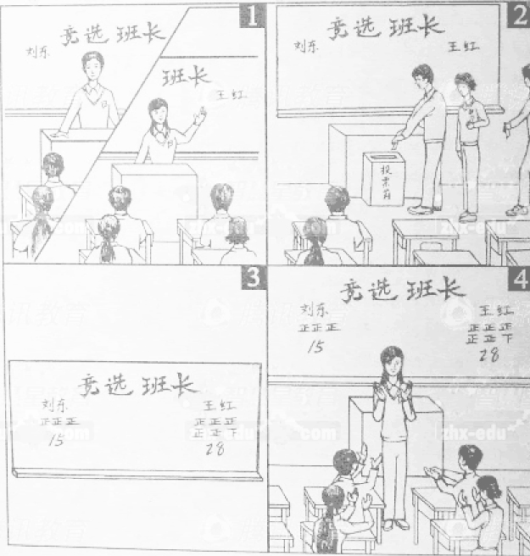

Dear Harry,
How are things going?
Last Monday.(请将情景作文写在答题卡二第一页指定区域内)
Best wishes,
Li HUa

- 开放作文（15分）
请根据下面提示，写一篇短文。词数不少于50.
In your English class,you are asked to describe the following picture and explain to your classmantes how you understand it.
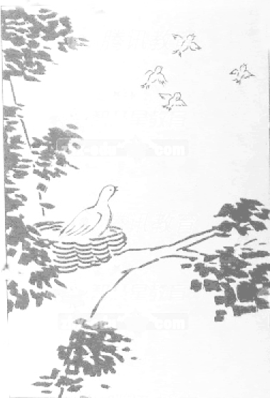

参考答案
第一部份：听力理解（共两节，30分）
第一节（共5小题；每小题1.5分，共7.5分）
1.A 2.B 3.C 4.A 5.C
第二节（共15小题；每小题1.5分，共22.5分）
6.B 7.C 8.C 9.C 10.A 11.A 12.A 13.B
14.C 15.B 16.B 17.B 18.A 19.C 20.B
第二部分：知识运用（共两节，45分）
第一节 单项填空（共15小题；每小题1分，共15分）
21.A 22.B 23. D 24.D 25.B 26.C 27. C 28. A 29.B 30.B 31.D 32.C 33.D 34.C 35.A
第二节 完形填空（共20小题；每小题1.5分，共30分）
36.B 37.A 38.C 39.B 40.D 41.C 42A 43D 44B 45 A 46.B 47.D 48.C
49.D 50.C 51.A 52.B 53 A 54 C 55D
第三部分：阅读理解（共20小题；每小题2分，共40分）
56 A 57C 58A 59B 60B 61C 62C 63B 64D 65A
66 D 67B 68B 69D 70A 71C 72D 73B 74C 75A
第四部份：书面表达（共两节：35分）
- 情景作文（20分）
- 内容要点：
- 演讲
- 投票
- 结果
- 祝贺
- 说明：
内容要点可用不同方式表达
- One possible version：
Dear Harry,

How are things going?

Last Monday,our class held a monitor election.This was our first electiong,so everyone was excited.Two of my classmates took par in the race;Liu Dong and Wang Hong.They each gave a speech telling us what they would do when they were elected.Then we voted for the monitor.Theresult was 28 to 15 in Wang Hong’s favor.Wang Hong because our new monitor.The whole class cheered for her,and she promised to do the best she could for us all.

Best wishes,
Li Hua

- 开放作文（15分）
One possible version:
In this picture,a mother bird stays in her nest in a big tree,watching her babies flying away.I think the mother bird must be bery proud of her children,who are able to find their own food now.But she may also feel a sense of loss since they no longer need her day-to day care as they used to.This picture shouws very well the mixed feelings of parents when watching their children grow up.For my parents,things will be much easier.We will set up a family blog to post our photos,journals,and even audios.Once I leave for college,we can conveniently share our experiences and support each other no matter wherer we are.Their “nest”will never be empty.

